**Muhammad Athar Abbas**

**SP25-BSE-082**

**Applications of ICT**

**Lab Final Exam**

# **Question 1:**

## Part C:

**Program:**

name = input("Enter your name : ")

marks1 = int(input("Enter marks for Subject 1 : "))

marks2 = int(input("Enter marks for Subject 2 : "))

marks3 = int(input("Enter marks for Subject 3 : "))

average_marks = (marks1 + marks2 + marks3) / 3

status = ""

if average_marks >= 40:

    status = "Pass"

else:

    status = "Fail"

print("\nStudent name : " , name)

print("Average Marks : ", average_marks)

print('Result : ', status)

**Output:**

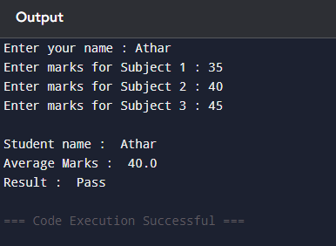

## **Part b:**

**Program:**

**HTML:**

**<!Doctype html>**

**<html lang="en">**

**<head>**

**<link rel="stylesheet" href="style.css">**

**</head>**

**<body>**

**<h1>Student Profile</h1>**

**<h2>Muhammad Athar Abbas</h2>**

**<img width="200px" height="200px" src="D:\html\pexels-stefanstefancik-91227.jpg" alt="Profile_image">**

**<h3>My Introduction</h3>**

**<p>Hi, I am Athar Abbas, i am currently studying Software Engineering at COMSATS Lahore.<br> My hobbies are reading and traveling.</p>**

**<h3>My Skills</h3>**

**<ul>**

**<li>Front End Development</li>**

**<li>Game Development</li>**

**<li>Python</li>**

**</ul>**

**<h3>My Projects</h3>**

**<ol>**

**<li>A playing cards game</li>**

**<li>A library management system</li>**

**</ol>**

**<footer>**

**<p>My Email: sp25-bse-082@cuilahore.edu.pk</p>**

**</footer>**

**</body>**

**</html>**

**CSS:**

**body{**

**background-color: #f0f8ff;**

**}**

**h1,h2,h3 {**

**text-align: center;**

**}**

**p {**

**margin-left: 25px;**

**}**

**img{**

**width: 150px;**

**border-radius: 50%;**

**margin: 0 600px;**

**}**

**ul{**

**padding: 10px;**

**margin: 25px;**

**}**

**footer{**

**background-color: blue;**

**color: white;**

**text-align: center;**

**}**

**Output:**

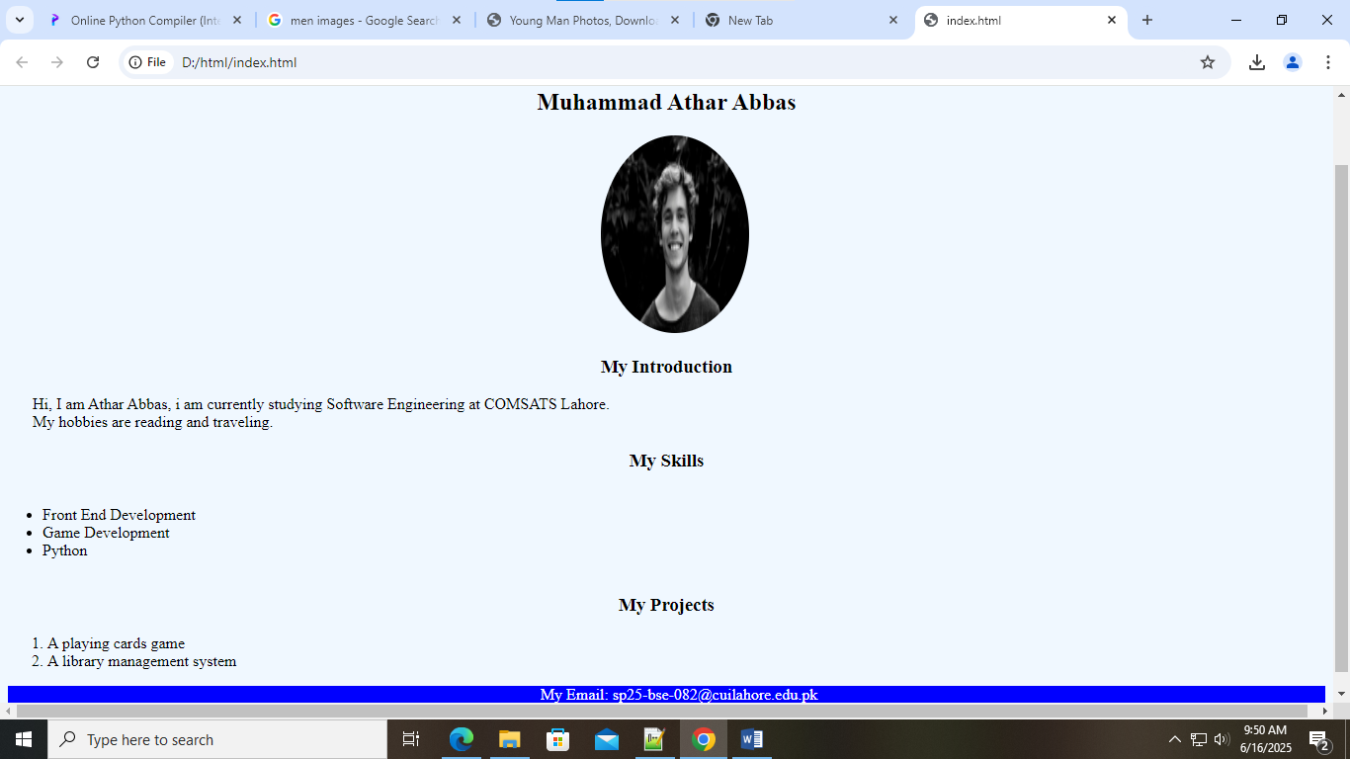

## **Part A:**

Excel File:

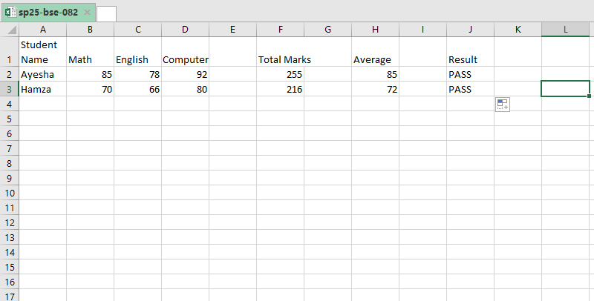

* SUM formula:

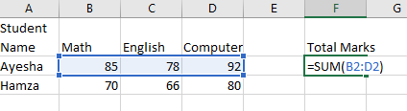

* Average Formula

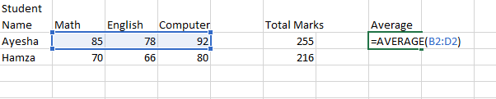

* Result, If else condition:

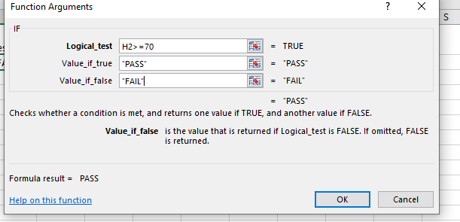

-------------------------------------------------------------the end---------------------------------------------------